**Hadoop Installation in Windows**

Step-1: Download Jdk 1.8 and install

Step-2: Download Hadoop 3.3.0.tar file and extract through 7-Zip

Step-3: Copy hadoop-3.3.0 file in C: Drive

Step-4: Set Path

4.1 Open Environment Variable and click new in user variable



4.2 Than click path in system variable

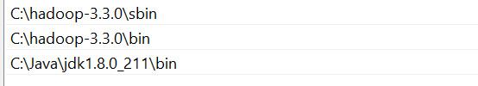

Step-5 Change all file given below in C:\hadoop-3.3.0\**etc** folder:

# For core-site.xml

<property>

<name>fs.defaultFS</name>

<value>hdfs://localhost:9000</value>

</property>

# For hdfs-site.xml or https-site.xml

<property>

<name>dfs.replication</name>

<value>1</value>

</property><property>

<name>dfs.namenode.name.dir</name>

<value>C:\hadoop\data\namenode</value>

</property><property>

<name>dfs.datanode.data.dir</name>

<value>C:\hadoop\data\datanode</value>

</property>

# For mapred-site.xml

<property>

<name>mapreduce.framework.name</name>

<value>yarn</value>

</property>

# For yarn-site.xml

<property>

<name>yarn.nodemanager.aux-services</name>

<value>mapreduce_shuffle</value>

</property><property>

<name>yarn.nodemanager.auxservices.mapreduce.shuffle.class</name>

<value>org.apache.hadoop.mapred.ShuffleHandler</value>

</property>

Step-6: Now delete **bin** folder in Hadoop 3.3.0 and pest bin folder store in

hadoop_bin_file_and_dll_erro_fix_file this folder.

Step-7: Now copy msvcr120.dll and pest inside System32 folder. C:\Windows\System32

Step-8: Create data folder inside Hadoop 3.3.0 and also create namenode and datanode folder inside data folder.

Step -8: Open cmd as Administrator and write command

hdfs namenode -format

and follow the step command:

start-dfs.cmd

start-yarn.cmd

and than open localhost:9870

For ResourceManager Cluster: localhost:8088

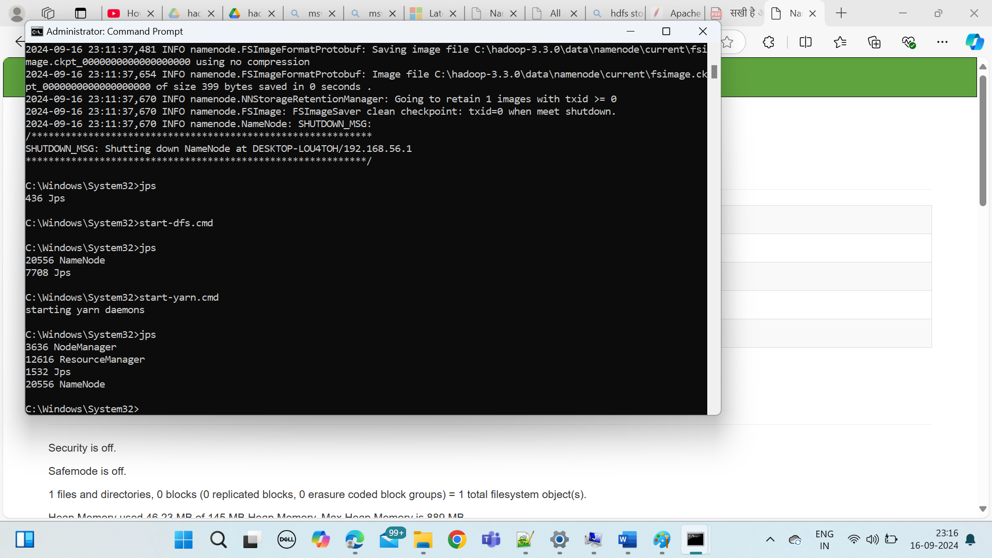

Step-Last For Stop command stop-all.cmd